**Objective: To observe the congestion window variation in different TCP variants.**

**Description:**

The NS2 script named “tcpvariant.tcl” simulates a topology with 4 nodes, with a TCP connection between 2 of the nodes. It produces a result file which captures the congestion window every 0.5 seconds. The gnuplot.txt file can be used to plot the congestion window against time.

Run the tcpvariant.tcl script with the following variants of TCP: reno, highspeed, cubic, compound

Verify that you get the graphs as those included in this folder.

**Steps and Observations:**

1. As root, open the “tcpvariant.tcl”
2. Look for the variable “TCP_Name”. Set the value to “reno”
3. Run the tcl script.
4. This will generate the following files:
   1. reno-configuration - displays the network parameters you ran the script with)
   2. reno-result0 – logs the congestion window vs time output (in text format)
5. Open the “gnuplot.txt” file.
6. Edit the file to reflect the following:

set out “reno-cwnd.png”

plot “reno-result0” u 1:2 w li

1. Run “gnuplot” to go into the gnuplot command prompt
2. Execute all lines, one by one, from the file “gnuplot.txt” on the gnuplot command prompt
3. This will generate the cwnd.png named appropriately, as given in the gnuplot.txt file
4. Open the file explorer, and view this .png files.
5. Repeat the same by editing the tcpvariant.tcl, gnuplot.txt files for the following TCP variants:
   1. compound
   2. cubic
   3. highspeed
6. Observe the difference in the congestion window pattern for these TCP variants

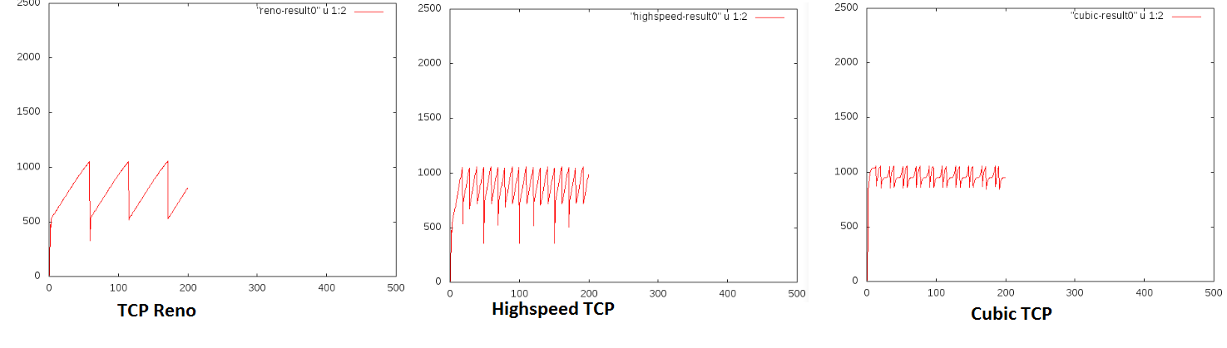

**Exercises:**

1. Change the configuration parameters in the tcl file, and observe the effect on the changes on the congestion window, for each of these variants.
2. Try the same script for other variants of TCP, supported by NS2.